Tobii Eyetracking Recording Analysis Software (TERAS)

Contents

Introduction 3

Design 3

Home menu 4

Import/Export 7

Import Modules 7

Export modules 9

Analysis tools 14

QR Marker Configuration 21

# Introduction

This software is an OpenSource software designed to help investigate and analyze Eyetracking recordings recorded by the Tobii Glasses Pro 3. The native Analysis software is expensive and may not provide the control researchers need to properly investigate the data recorded by the apparatus.   
As an ace up TERAS’s sleeve the software is capable of understanding and analyze eyetracking recording according to a custom created space, which is defined by QR markers, thus you are capable understand exactly what is going on within that field even though the Tobii Glasses are mobile and the users are capable of looking wherever they want.

# Design

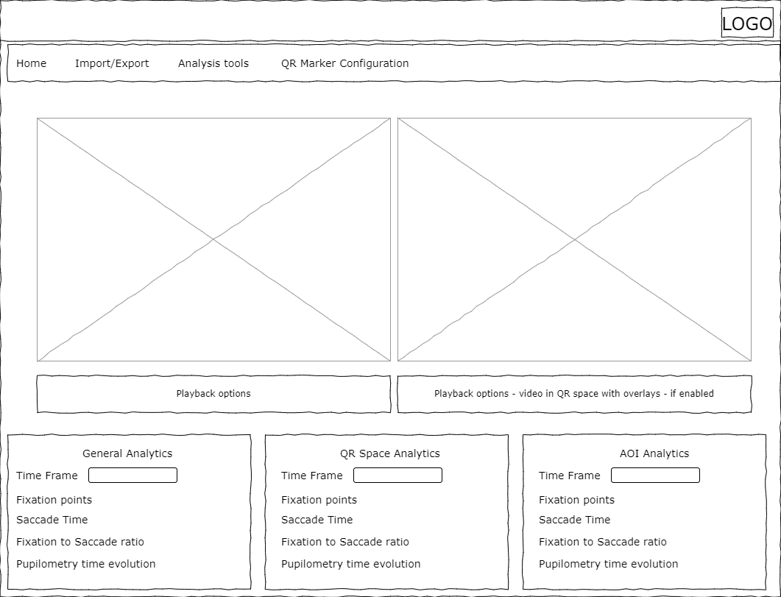

The software is a simple application which should afford the most essential eye-tracking analysis tools, while being able to analyze the data within QR space, which is the coordinate system created within the QR markers. In the design there are the four menu items at the top. Home, Import/Export, Analysis Tools, QR Marker Configuration. Consisting of the most important features in order to analyze the data from your eye-tracking experiment.

The video streams below shows two distinctive videos the first to the left is the video recording from the tobii glasses pro 3 camera showing where they are pointing and the current gaze position. The other video is the QR space found in the video. In this space there can be super imposed scan paths, fixation points, numbers of fixations, heat maps, AOIs. All depending on which tools that has been enabled and configured. As standard fixations, saccades and standard markers are configured. With the two video streams the true video will tell what is in it while the QR space will tell how the gaze is within that space, and the analysis features superimposed.

The lower three boxes provides instant feedback upon the current video streams and configurations. A timeframe can be set within each of them to provide a short summary of analysis points related to both space and time.

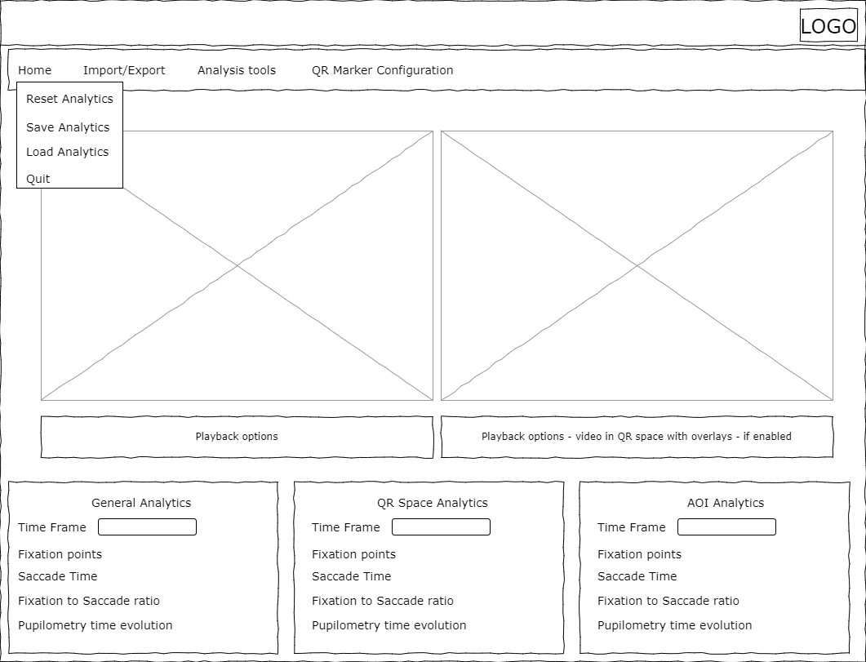

## Home menu

In the Home menu the user is capable of reset all current analytics. Save the analytics, load analytics and Quit the program. Then the user is capable of starting over, save and continue working where the user left off. Below is three mock-ups of the three items

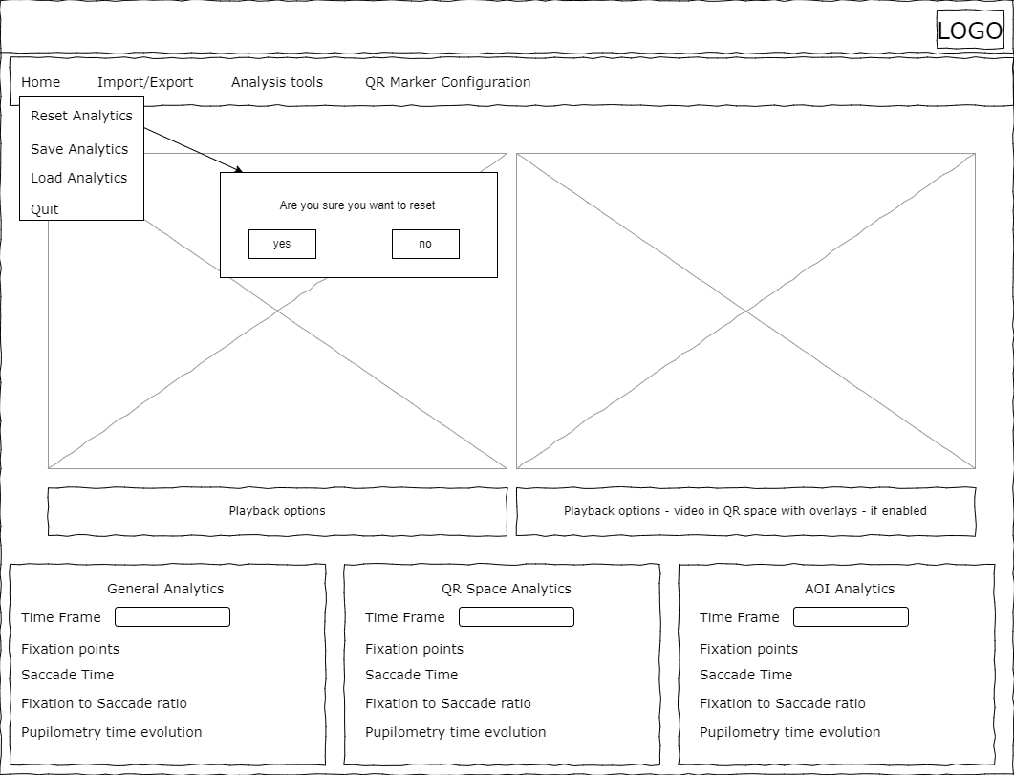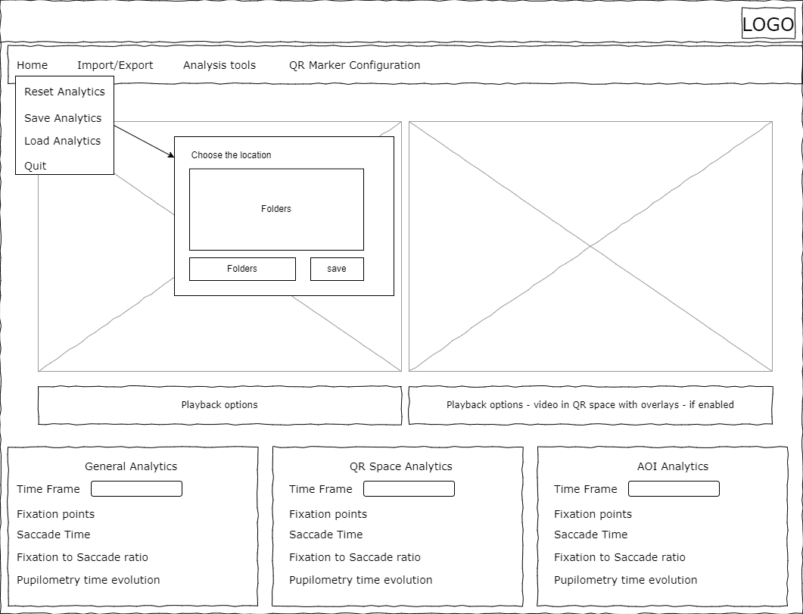

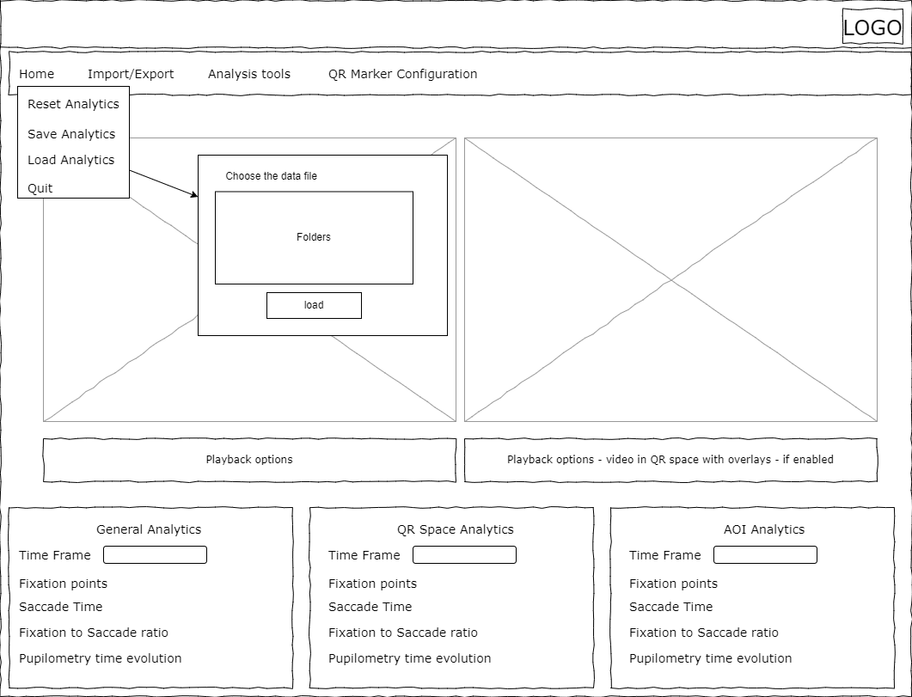

## Import/Export

In the Import/Export menu item different import and export opportunities can be found.

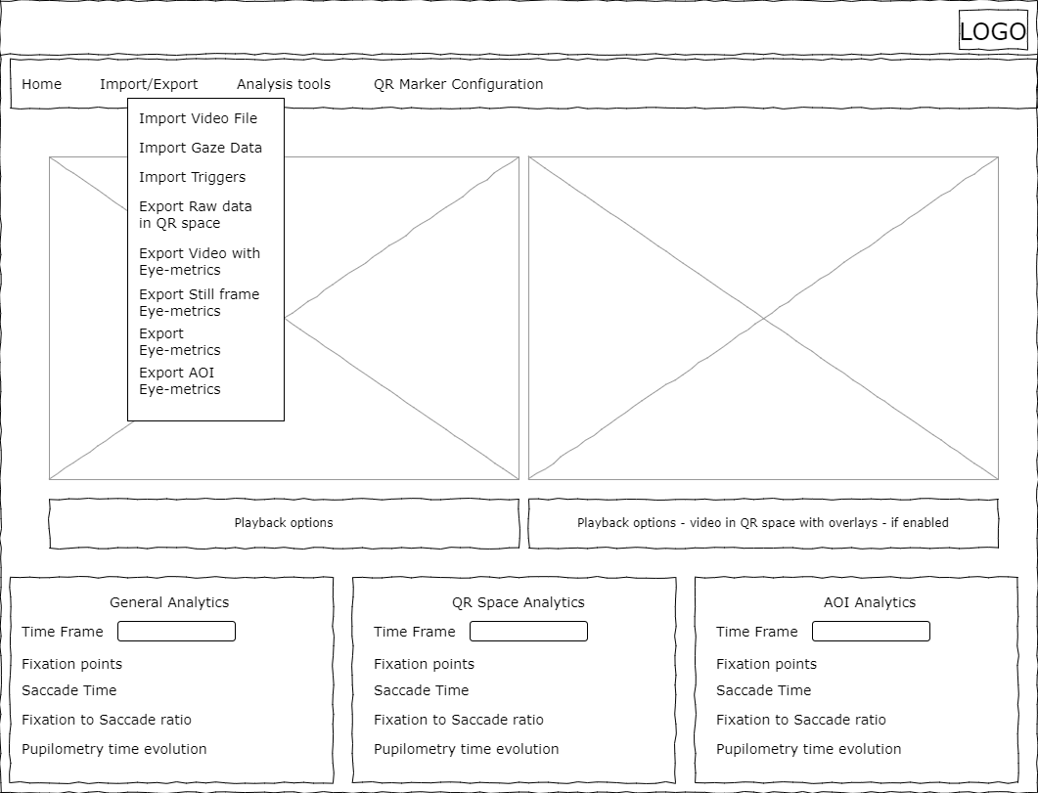

### Import Modules

The import are important part of this analysis program as it provides the raw data from which all the different metrics can be extracted. Import video file provides the user with the ability to import the video created by the eye-tracker. Gaze data is the raw Json data file provided by the tobii Glassses pro 3. The file can be found if you open the gazedata.gz with an unzipping program like 7-zip. The normal .gz file is unreadable by any other means.

Import Triggers imports a file consisting of time and triggers at certain timestamps, the format of which is still unknown.

Below is the wireframes for the two of the import modules, as they are quite similar to each other.

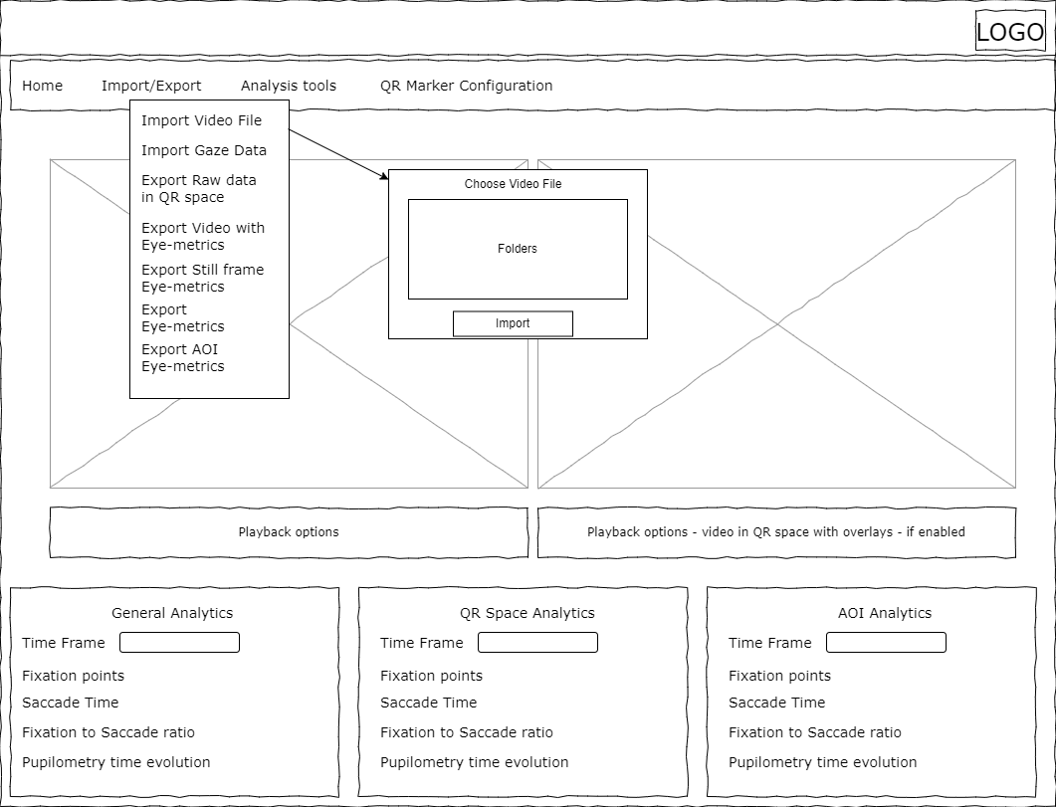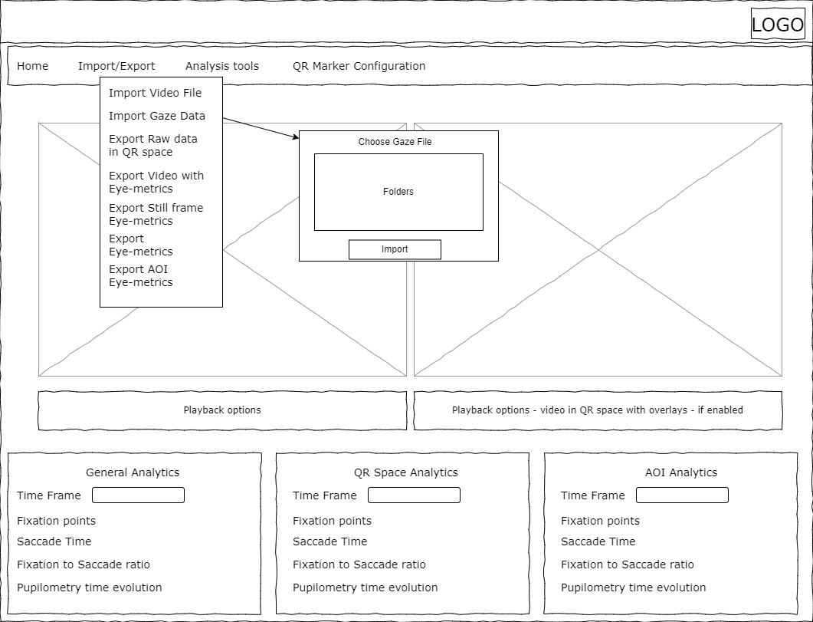

### Export modules

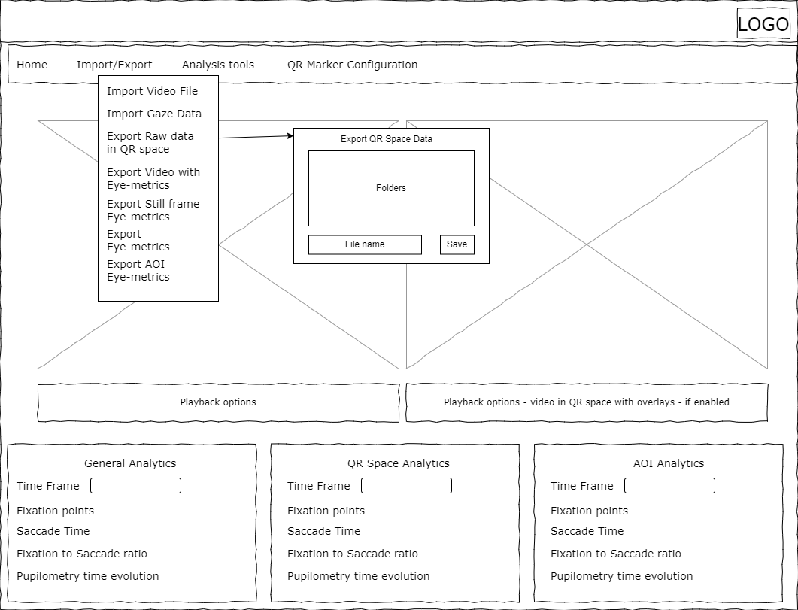

In the first export module the eye-tracking data is converted to QR space and exported in its raw form as a readable csv file. In the file you will see 2D gaze coordinates denotes with an x and y coordinates. If the coordinate is 1,1 it means the position is at the upper left QR marker, if the coordinate is 0,0 then the gaze position is at the lower right corner. Besides the coordinates the pupil diameter for left and right eye is stored. If a trigger file is imported the triggers will written into the csv file. Thereby will the csv file be formatted as the following:

|  |  |  |  |  |  |
| --- | --- | --- | --- | --- | --- |
| Time | Gaze pos x | Gaze pos y | Left pupil dia | Right pupil dia | triggers |
|  |  |  |  |  |  |

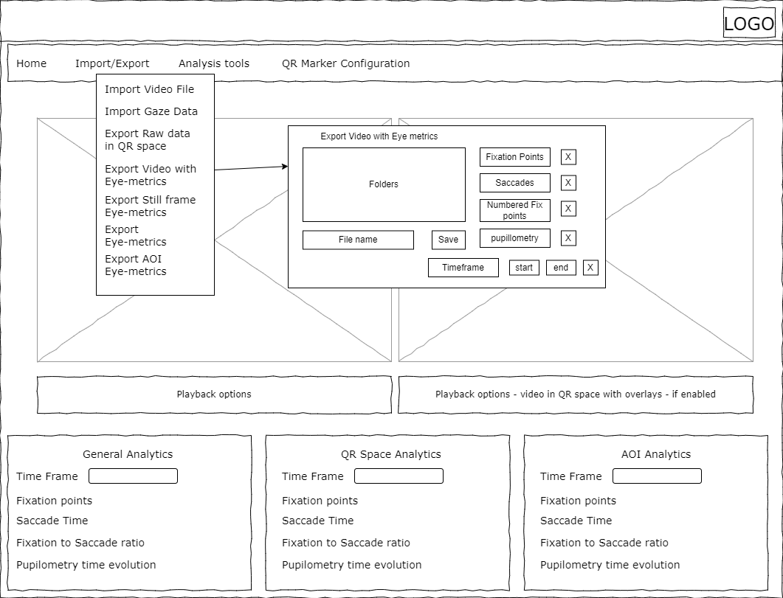

The next export module concerns the video with eye-metrics superimposed on the video. The size of the video is alterable, thus you can choose to display a single event of interest for you research presentation. You can choose to superimpose fixation points, having them numbered, saccades, evolution of heat maps and pupillometry. Assisting the video file a csv file will be exported, displaying the eye-metrics in numbers.

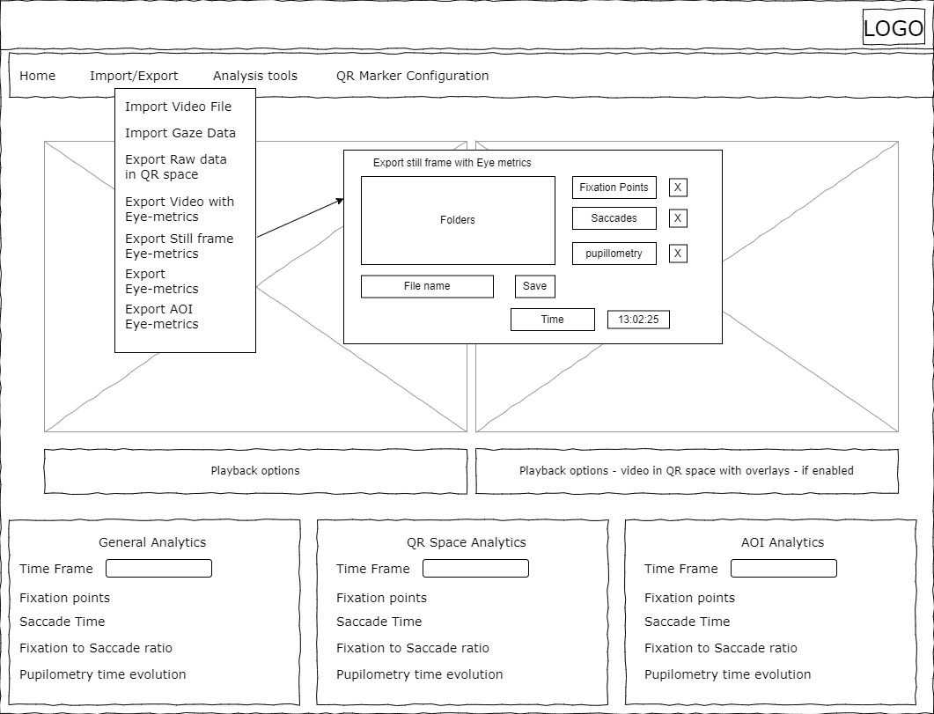

This export module is a bit different than the previous, it exports a single frame on which the current saccade, fixation point or pupil dilation.

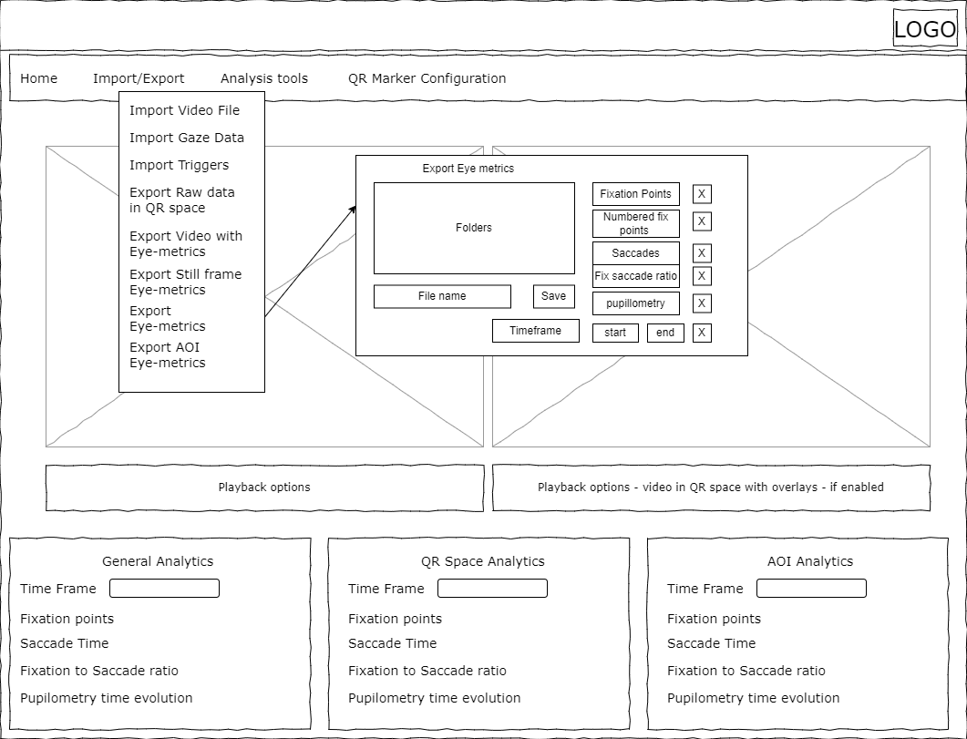

This export module provides the users with the possibility to provide the program with a certain timeframe, as standard it will be the total length of the video. Then the users can choose all the eye-metrics needed for further analysis. As standard there will be time, then the users can choose to have fixation points, which will include: where, when, how big, for how long and the order of fixation points. Saccades, which give the user the following: when, where and how long. With Fixation points and Saccades a Fixation to Saccade ratio can be provided in the csv file. When pupillometry is checked off the user is provided with the raw pupillometry data, the smallest and biggest dilation, the biggest dilation difference in the timeframe and when the smallest, biggest and creates difference is captured.

In total the csv file will look like the following :

|  |  |  |  |  |  |  |  |  |  |  |
| --- | --- | --- | --- | --- | --- | --- | --- | --- | --- | --- |
| Time | Fix no. | Fix Loc | Fix radius px | Fix time length | Sac No | Sac time length | Sac size px | Sac Start Loc | Sac End Loc | Fix/Sac Ratio |
|  |  |  |  |  |  |  |  |  |  |  |
| L pup  s size | L Pup s loc | L Pup b size | L Pup b loc | R Pup s Size | R Pup s Loc | R Pup b Size | R Pup b Loc | L Max Dif Size | R Max dif size |  |
|  |  |  |  |  |  |  |  |  |  |  |

The last export module provides the same options as the one above, the main difference is that it is related to an Area of Interest (AOI), which is a defined virtual space within the QR space, as this space is fixed. Compared to camera space which is moving thus a defined AOI in camera space required fine computer vision algorithms to properly define the locations.

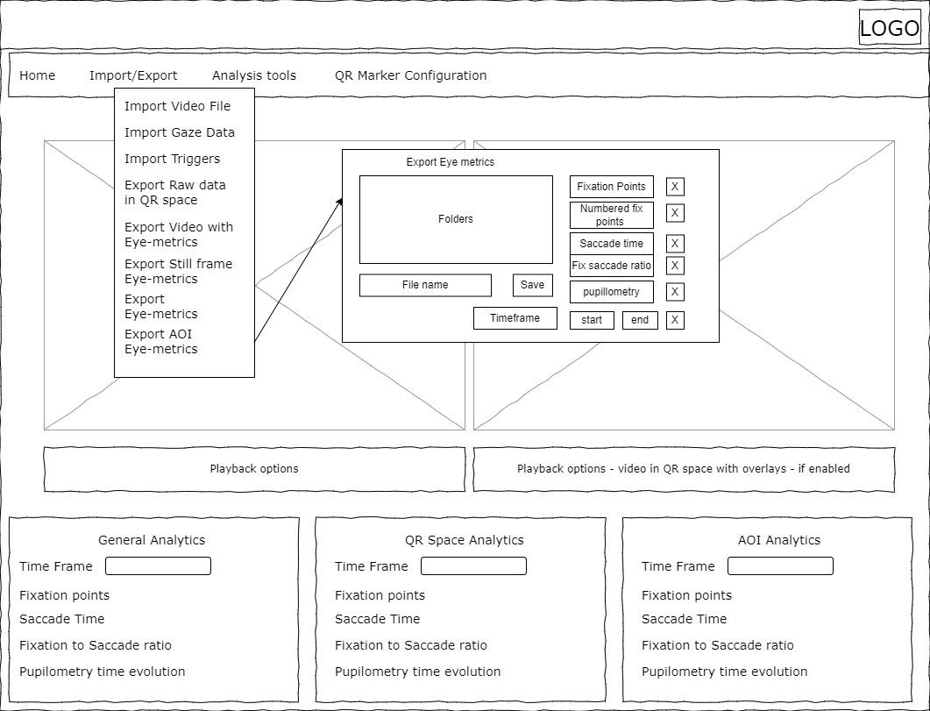

## Analysis tools

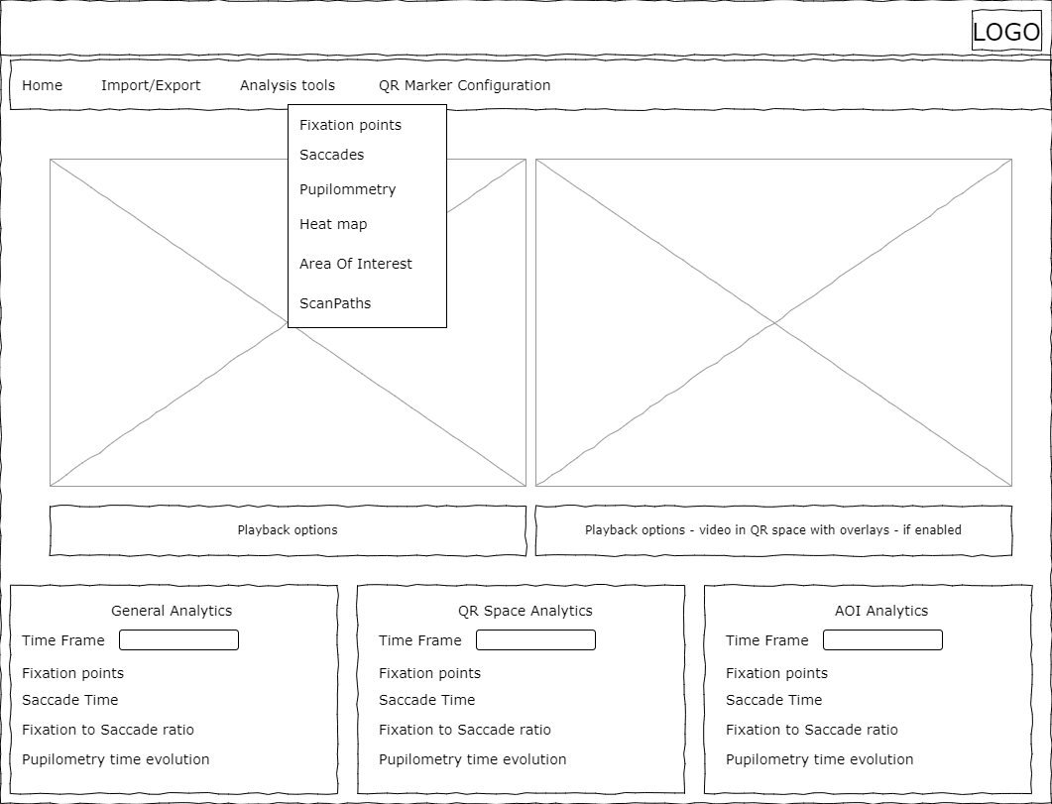

The analysis tools menu consist of means of analyzing Eye-tracking data. Some of the menu items consist of configuration menus in order to tell the system how you will like it to understand different eye-metrics e.g fixation points.

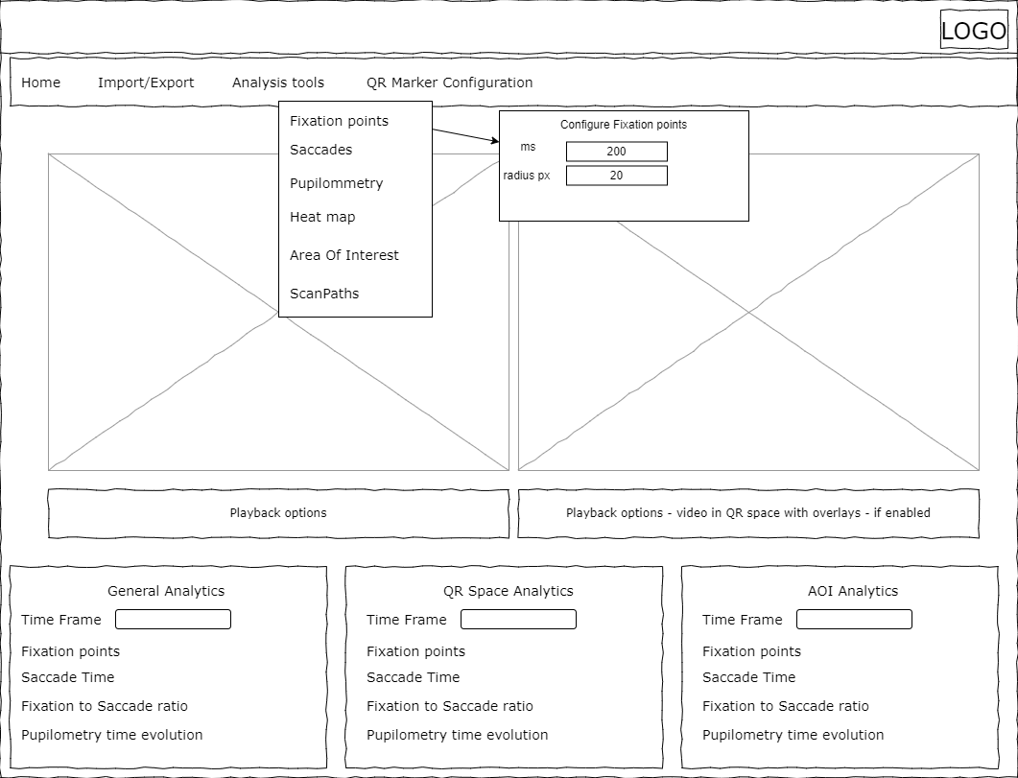

In the menu point regarding Fixation Points you are able to define what a fixation point is. For how long does the subject needs to be looking at an area with a specific pixel radius in order for the program to understand it as a fixation point? As a standard the setting is set to be 200 ms within a radius of 20 pixels. The radius and thus he middle of the point resets every time the subject moves its gaze outside the given parameters.

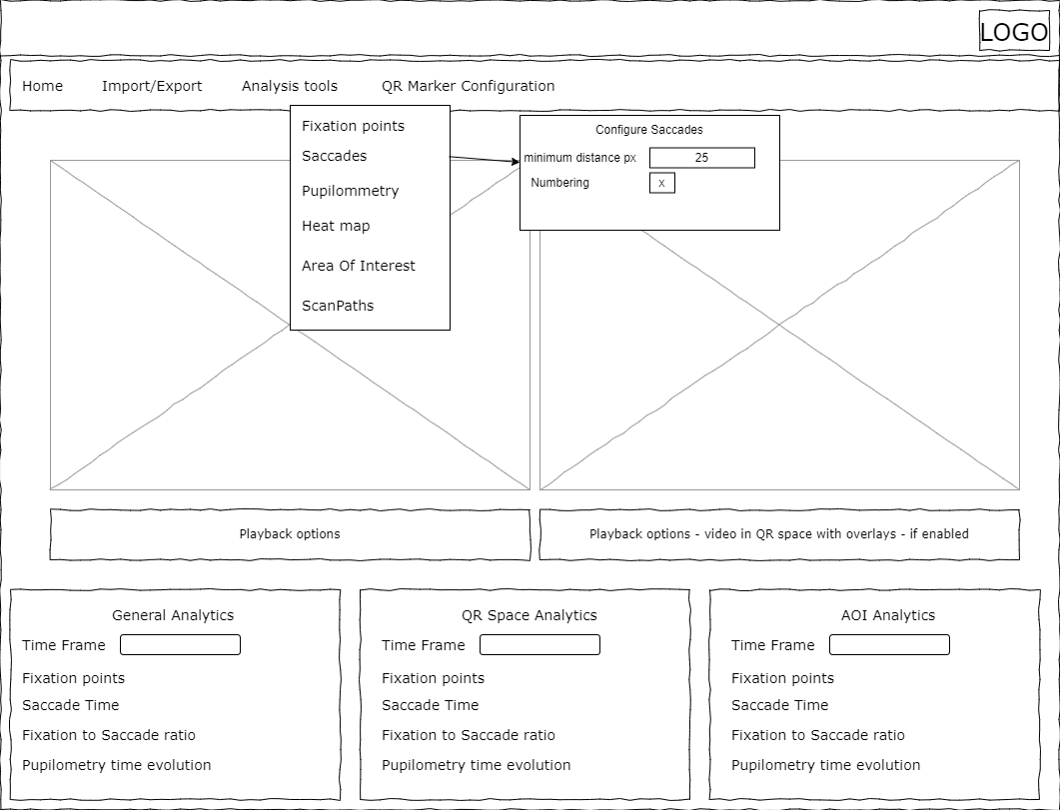

For saccades you are able to define what the minimal distance between point A and Point B needs to be before it is considered a Saccade. The Saccade measure will be initiated when the fixation point parameters has not been met. E.g. the user gazes at Point A for 50ms, moves gaze 10 pixel, gazes at it for another 100 ms, then moves the gaze 20 pixel. Now we know the subject has moved its gaze 30 pixels within 150ms, which is shorter that 200 ms, longer than both 20 and 25 pixels. Therefore, is the fixations point calculation be reset and the whole 150 ms is called a saccade, traversing from Point A to Point B. Apart from the distance parameter numbering of saccades can be enabled and disabled.

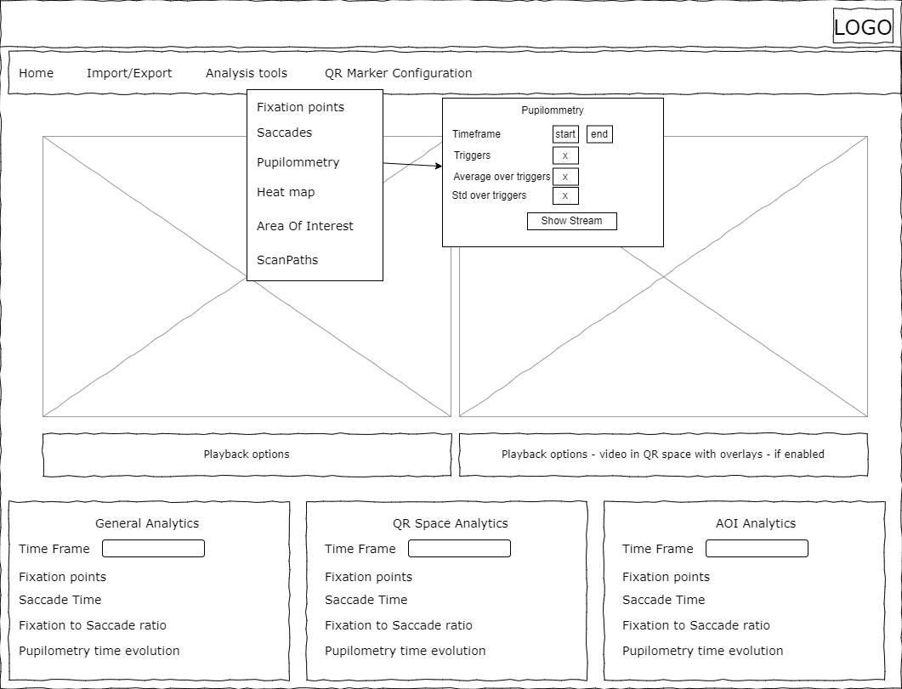

Pupillometry is a different beast entirely. In this menu you get access to configure a pupillometry graph and the data within it. First the time frame within which you want to analyze the pupil diameter. Then you tell the system whether or not triggers are embedded in the system. This very mark will change the view from a raw stream view to a trigger based view. The trigger-based view enables a custom amount of time before trigger and after trigger time. Then the system know how it shall average the signal and portray standard deviation over the very plot. These are also enable/disable able as seen in the menu above.

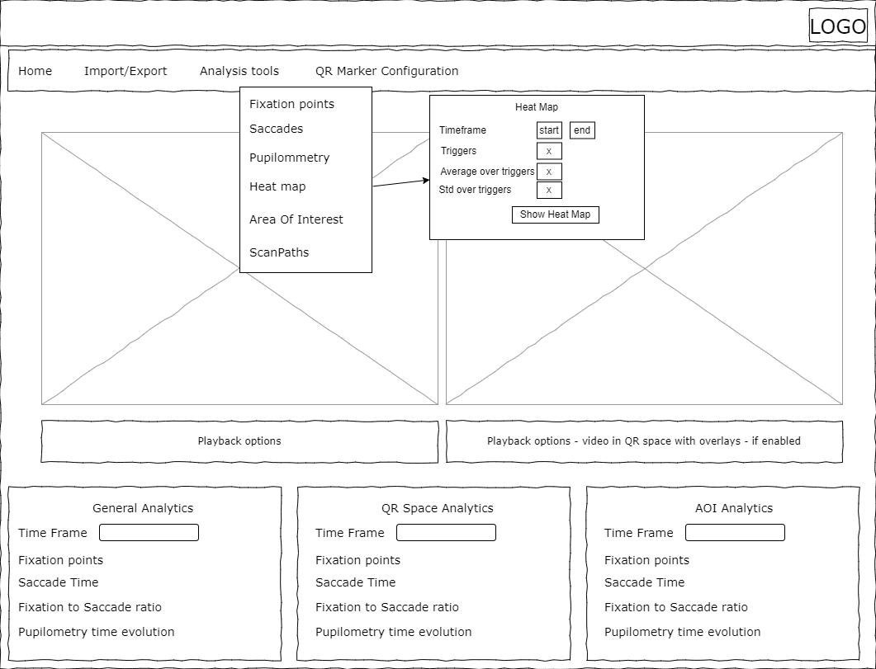

For the Heat map module the time frame is configurable, whether or not triggers should be taken into consideration and if average and or standard deviation maps shall be presented in order to provide a visual representation of the data over time and how much it varies.

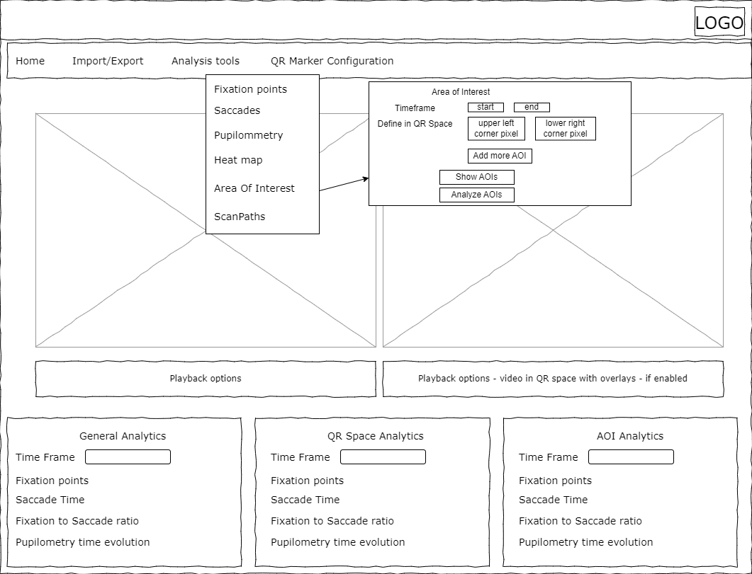

In the area of interest menu point you can define within the QR space areas of interest. The time frame within this analysis has to occur, how big and where they are. All AOIs are rectangles, and will not be of any other shape in this version of the system. In the menu point you are able to just view where they are to confirm your AOI configuration. Lastly, the AOIs can be analyzed for different Fixation and Saccade metrics.

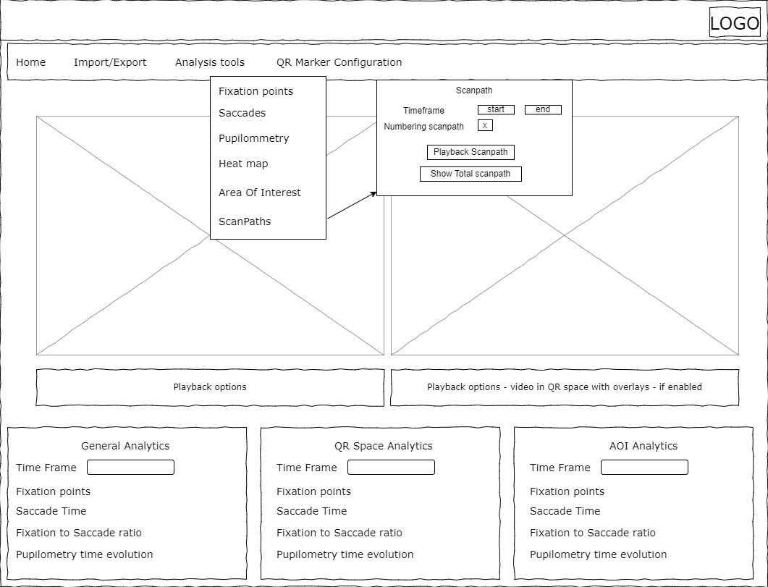

The last analysis menu point is ScanPaths, this menu points allows the user to define a timeframe from within a saccade path can be numbered and shown. This can be shown either as a summed total or as a video portraying how the scan evolves over time.

## QR Marker Configuration

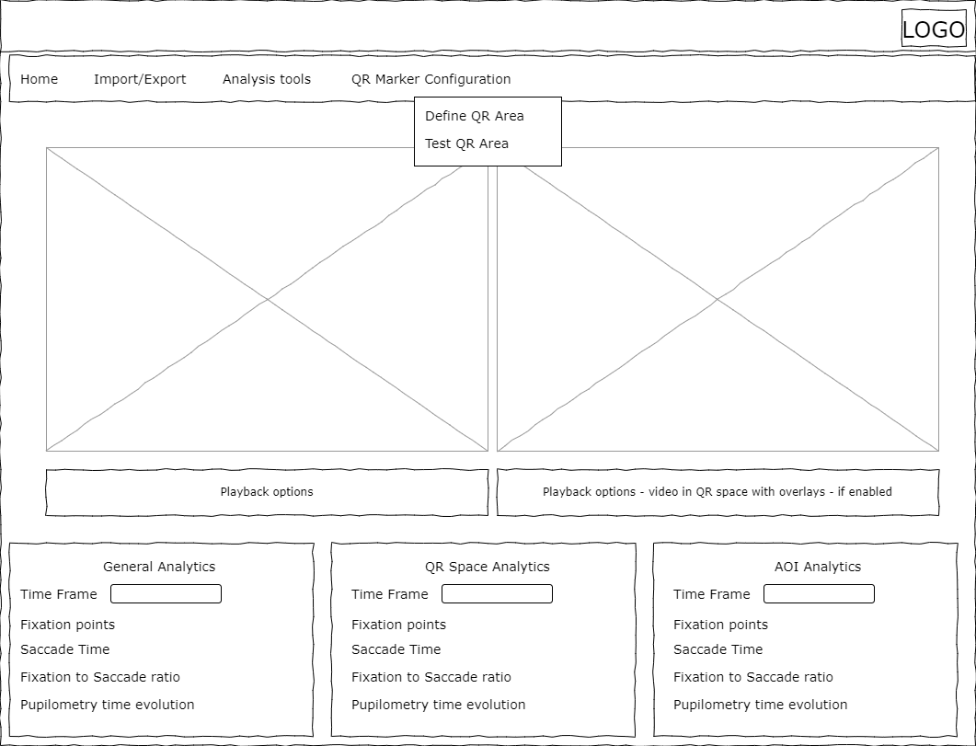

In the QR Marker Configuration menu you are able to define the QR area and test it. It is relevant for you to test the area to confirm that you indeed have configured the area correctly.

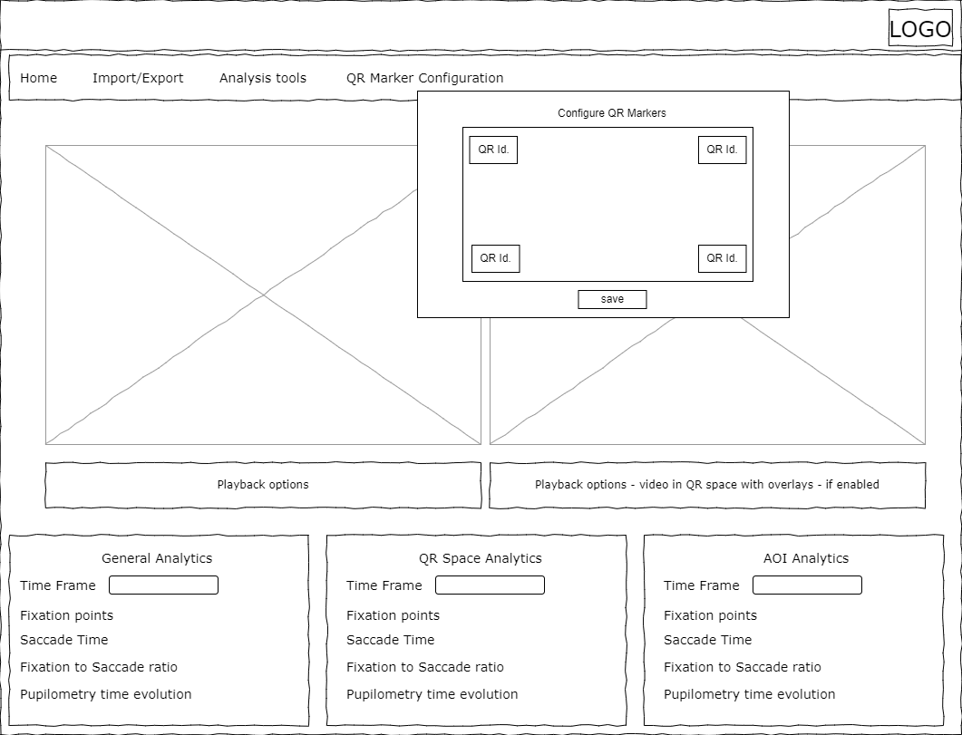

Within the Define QR area you can instruct the program to see and react on certain QR code ids in this way you can flexibly find and use the QR values as you will as long as they provide a number when scanned. The standard configuration operates with the numbers 1-4. 1 being the upper left corner and 4 being the lower right corner.

# Implementation management

The tas